Client-server
All work with application objects, reading and writing the data from/to database is performed only on the server side. Forms and command interface functionality is also implemented at server. The preparation of form data, the arrangement of elements, the recording of form data after the change is performed are also work at server.
A prepared at server form is displayed on the client side, as well as data entering, server calls that made to record the entered data and other necessary actions. Similarly, the command interface is formed at server and displayed at client. Also, reports are generated entirely on the server side and displayed on the client side.
Platform mechanisms are focused on minimizing the amount of data transferred to the client computer. For example, the data of lists, tabular sections and reports are not transferred from the server immediately, but as they are viewed by the user.
The server runs:
- database queries,
- data recording,
- posting documents,
- various calculations,
- performing data processing,
- generating of reports,
- preparing forms for display.
The client runs:
- getting and opening forms,
- form display,
- “communication” with the user (warnings, questions…),
- small calculations in forms that require a quick response (for example, multiplying the price by the quantity at one row of a table),
- work with local files,
- work with commercial equipment.
How is it determined in what context the code will be executed? In the form module, compilation directives are used for this, such as:
- &AtClient
- &AtServer
- &AtServerNoContext
- &AtClientAtServerNoContext
The &AtClient directive specifies that the procedure or function will be executed in the context of the client application. In this procedure, the entire context of the form will be available: attributes, elements, and form parameters. This directive is used for all form client event handlers, as well as for procedures that describe local form commands.
The &AtServer directive is similar to the previous one, with the difference that the code is executed in the context of the server. This directive is used for all form server event handlersAlso, developers often use this directive for their own procedures to transfer code execution to the server. In what follows, the procedures preceded by this directive will sometimes be referred to as the form's server procedures. And the call of such a procedure from the client procedure we will call the context server call.
The &AtServerNoContext directive also specifies that the code will be executed in the server context, but the form context (attributes, elements, parameters) will not be available. This directive is also used by developers for their own procedures to transfer code execution to the server. Procedures and functions with this directive are used in the form module to execute code that can only be executed on the server, but not to transfer the context between the client and the server, because this can be an expensive operation (depends on many factors, such as the amount of form data, the speed of interaction between the client and the server, the power of the client machine, and others). We will call such procedures non-context server call.
And the final directive, &AtClientAtServerNoContext, specifies that a procedure or function can be executed in both client and server contexts. This directive is rarely used. Usually it is required in cases where you need to perform the same actions both when creating a form and during its life on the client. Then, instead of two identical procedures, one of which is executed on the server and the other on the client, one procedure is created with the directive &AtClientAtServerNoContext.
If no compilation directive is specified at the form module, then the platform assumes that &AtServer directive is being used.
The process of executing code on the client and server in forms corresponds to the general approach adopted in 1C:Enterprise: you can call server procedures from client procedures; after their execution, code execution returns to the client. It is impossible to force code execution in the opposite direction, from the server to the client, i.e., client procedures cannot be called from server procedures.
Also context server method cannot be called from non-context client-server or non-context server methods.
At the Enterprise mode:
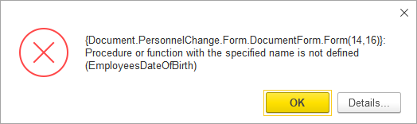

At the Designer mode:
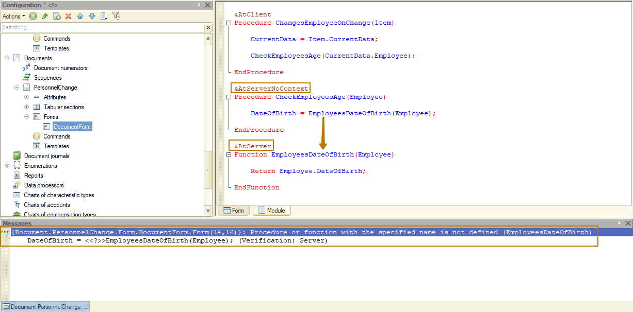
Let's move on to the modules. We will not analyze in detail the purpose of certain modules, for this we will have a separate lesson soon. Let’s briefly present the purpose of the main modules and consider them only in terms of code execution context.
The code is only executed on a server in:
- Object module (catalog, document, chart of characteristic types and other reference objects)
- Object manager module
- Record set module (registers)
- Some common modules, the execution context of the code depends on the properties of the module.
Let’s find out what is the purpose of object module, manager module and common module:
- The object module is designed to implement the behavior of a separate object instance (CatalogObject, DocumentObject, etc.). The object module contains procedures and functions that work with the object's data (ThisObject and object module variables), including situations when it is not yet been written to the infobase.
For example, an object module can contain:
- object event handlers
- procedures for filling an instance of an object.
- The manager module of an object is designed to place static functionality that is logically linked to a metadata object, but does not depend on a particular data object instance state. These can be procedures and functions:
- related not to one, but to a collection of objects. For example, these are functions for printing a list of objects; functions that return information common to all metadata object instances; procedures for updating infobase data that are associated with a metadata object; and other
- that work with an object written to the infobase. In such functions, the input parameter is a reference to an object. For example, these are functions for obtaining a printed form by reference to an object, procedures for generating movements by reference to an object, etc.
To perform the functions of the object manager module, no data object instance is required (CatalogObject, DocumentObject, and other).
- If the functionality cannot be referred to a particular metadata object, it is considered logically common for several objects. In this case, it should be placed in a common module.
Usually we use 4 types of common modules in 1C:
- Client - the code is always executed only on the client.
- Client-server - the code is executed in the context from which the call was made. If the call was from a client, the code is executed on the client. It should be understood that we are talking only about the code that can be executed on both the client and the server, according to the information from the beginning of this lesson.
- Server call - the code is executed on the server, but can be called from the client.
- Server - the code is executed on the server, can only be called from the server.
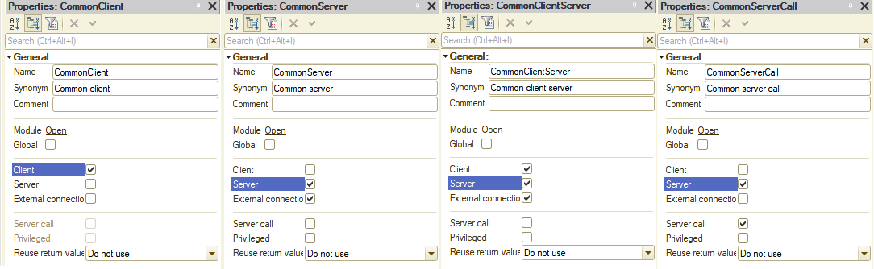

Preprocessor commands
Sometimes it is necessary to separate the executable code according to a more granular context. For example, a client method can actually be executed in a thin client, a thick client, a web client, a mobile client. Since some code cannot be executed in the web or mobile clients, or some conditions must be met for its execution, it is necessary to separate such code using preprocessor commands.
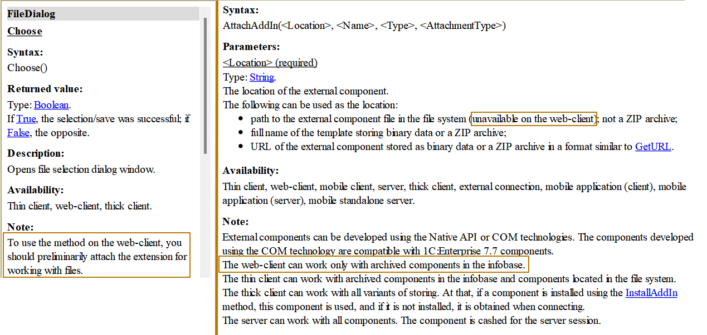
You can see that the Choose() method of the FileDialog object, which is used to open the file selection dialog box, requires the file extension to be connected when executed on the web client. Thus, the client code will require the separation of logic depending on the execution context.
The AttachAddIn() method used to attach an external component does not require any additional steps, but it has limitations - only archived components from the infobase can be used.
Example:
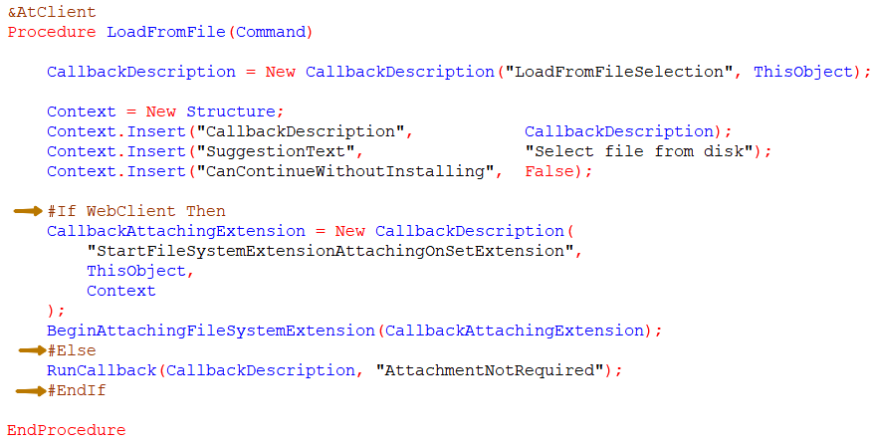

Context and non-context calls
Let's figure out what context and non-context calls are with examples. I have to add a check to the PersonnelChange document that the employee is over 16 years old on the date of the document. Since the date of birth of an employee can only be obtained on the server (because it requires reading of data from a database), let's create a server function that returns whether the employee is older than 16 or not:
&AtClient
Procedure ChangesEmployeeOnChange(Item)

CurrentData = Items.Changes.CurrentData;

If ValueIsFilled(CurrentData.Employee) And Not EmployeeIsOldEnough(CurrentData.Employee) Then
CurrentData.Employee = Undefined;
MessageText = StrTemplate(
"Employee %1 is under 16 years old on a document's date. You can't hire him",
CurrentData.Employee
);
Message(MessageText);
EndIf;

EndProcedure

&AtServer
Function EmployeeIsOldEnough(Employee)

DateOfBirth = Employee.DateOfBirth;

//If DateOfBirth <= AddMonth(Object.Date, -16 * 12) Then
// Return True;
//Else
// Return False;
//EndIf;
// We can simplify the code above to return the result of comparison as Boolean
Return DateOfBirth <= AddMonth(Object.Date, -16 * 12);

EndFunction
The AddMonth method adds the specified number of months to the passed date. We subtract 16 years from the date of the document and check the date of birth of the employee - it must be less than or equal to the resulting date.
The result in the case when an employee is 1 day younger 16 years old compared to the document date. We clear the selected value and display a message to the user:
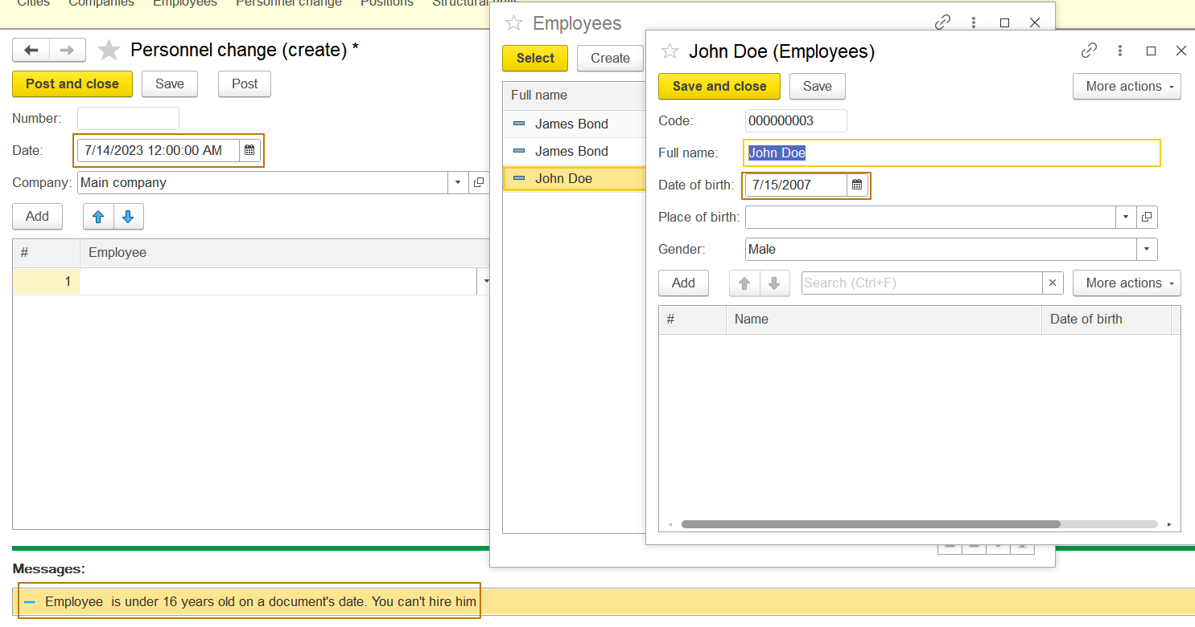
In the server function we got the date from the current document by accessing the Date property of the Object attribute (Object.Date). Let's change the preprocessor directive of this function to &AtServerNoContext and try to save the changes. Why should we do this? Each context server call creates additional load because the entire form with elements and attribute data is packaged and sent to the server. If we do not need to work with form data on the server, it is better to make a non-context server call.
First, just change the directive from &AtServer to &AtServerNoContext:
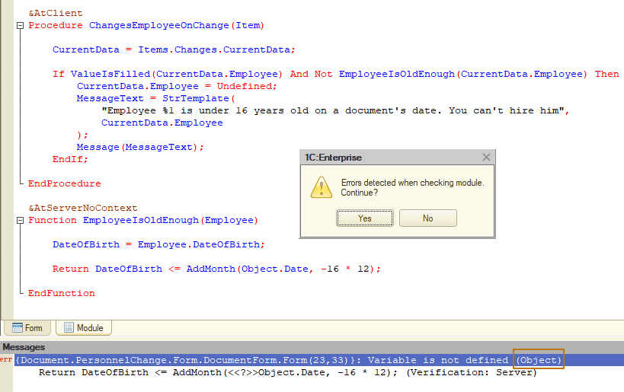
We see that an error occurs, because now the function does not know anything about what the Object is, for function it is an undeclared variable. The same will happen if we refer to the objects ThisObject (current form) or Items (elements of current form) and even to the server variables of the current module. This type of method can only operate on data that was passed to it directly.
Can we change this function so that it remains non-context, but works correctly? Yes, for this we need to add the Date function parameter:
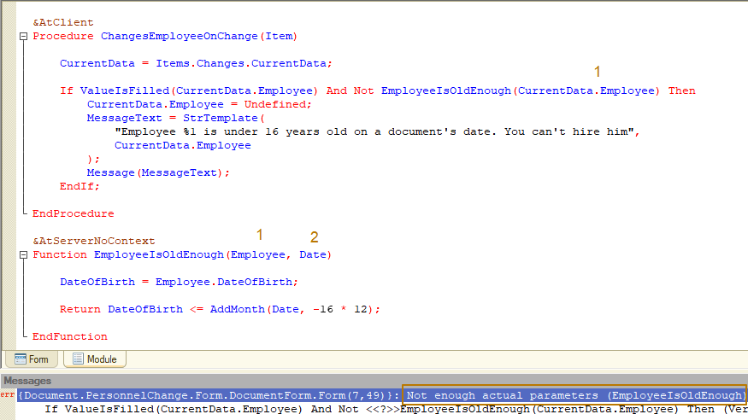
Now, when saving, the platform reports that there are not enough actual parameters to call the function. That's right, because now the function takes 2 required parameters - Employee and Date, and our call still passes only one. Let's fix this:
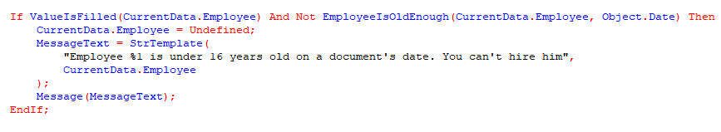
We save, run and check - everything works as it should.
Let's move on to &AtClientAtServerNoContext and see in what cases this directive can be used. Since there are even more restrictions in methods with such a directive - in addition to the absence of a context, we can only execute code that is available at both the client and the server, which means that database access is prohibited as well as interaction with a user. Typically, methods with this directive are used for simple calculations, such as calculating a total, filling in a title or other text, and the like.
Imagine a situation that we have a document with a table of products. This document has a Total attribute, which reflects the total amount of all products. With each change of the numerical indicators in the table, the total is recalculated, this happens on the client. However, there is a server method that adds a product to the table and then recalculates the discount. The discount must be calculated on the server, since its value is stored in the database and depends on the date and amount of the document (for example, on the date of 03.03. with a document amount of 1 million, the discount is 10%, and starting from the date of 06.06 and the document amount is 1 million - 12 %). If we leave the recalculation method on the client only, we will have to return from the server to the client, and then call the server again for subsequent operations. If we move the recalculation to the server, then there will be redundant server calls where they can be avoided.
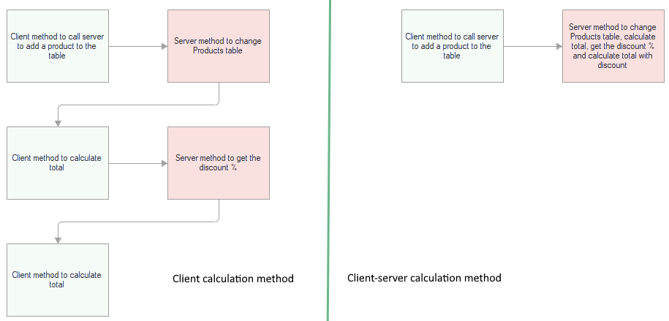
It would be possible to copy the client method and create exactly the same server method, but since this is code duplication (and when you change the calculation formula, you will have to edit the places with the recalculation code) and we have the opportunity to avoid this, it is still better to create a client-server non-context method. The previous approach can be used in emergency situations when the same action needs to be performed on both the client and the server, but context is still needed.
Thus, it is optimal to create a method that works on both the client and the server and call it from both contexts.
Code placement
The next important thing that I would like to consider is the use of suitable modules for the code. A fairly common mistake is placing code with business logic (logic related to certain algorithms of configuration objects, such as getting the current price of a product) in a form module. The form module is designed to work with the form, its attributes and elements, and also to interact with the user: this is the processing of the data entered by the user, displaying the result of a user's actions, notifying a user of certain events, etc.
Consider an example of working with the SalesInvoice document. This document contains the attributes Customer (Counterparties catalog) and Contract (CounterpartyContracts catalog). The Counterparties catalog contains the MainContract attribute. We need to implement an algorithm that populates the SalesInvoice document's Contract attribute with the MainContract value whenever the Customer attribute changes in the document.
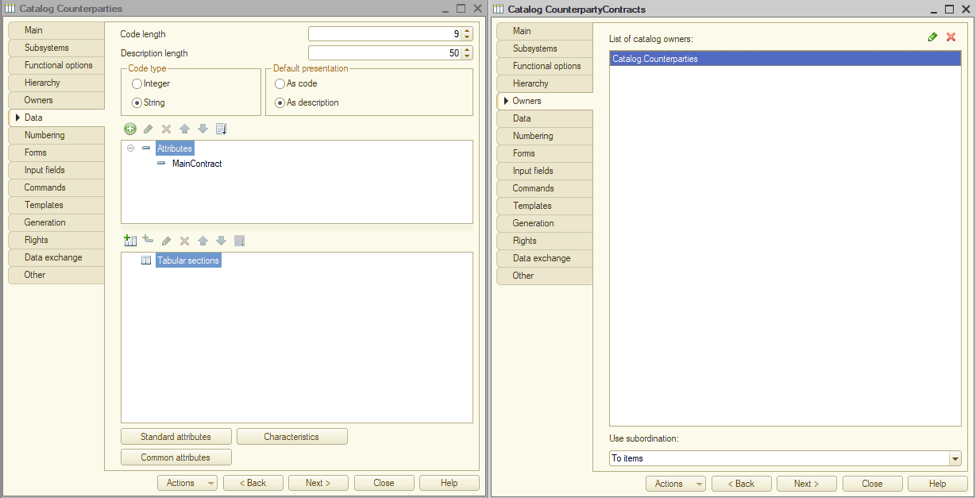
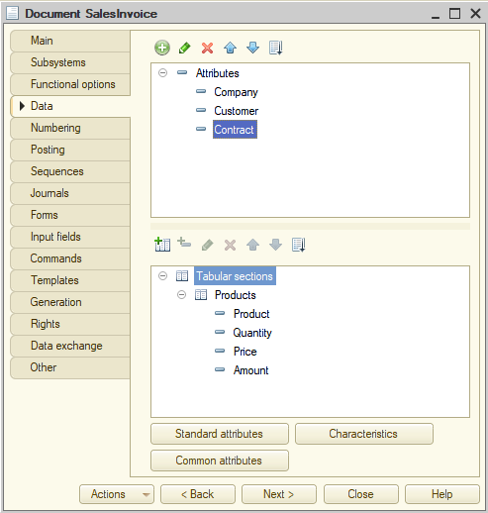
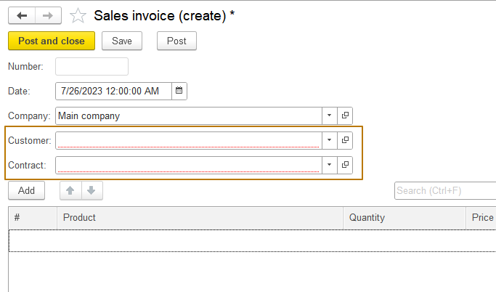
When changing the Customer attribute, the value of the Contract attribute must be changed to the main contract of the customer:
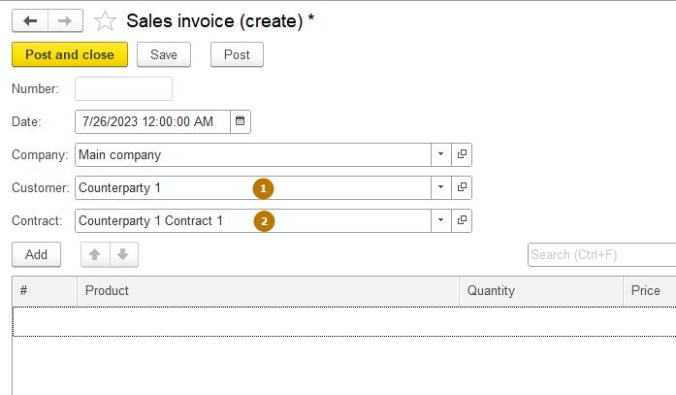
Let's create this algorithm: I assign an event handler to the OnChange event of the Customer field, then I write the code that receives the main contract from the selected counterparty.
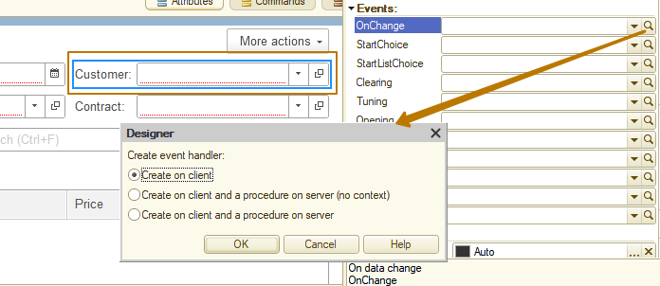
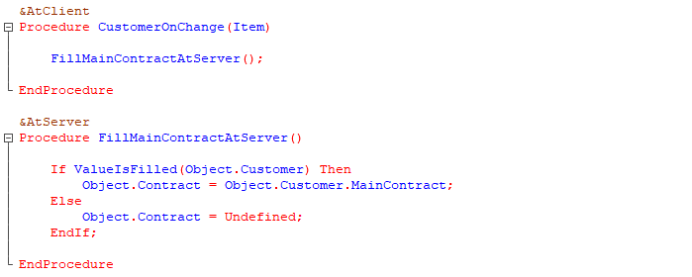
Why is the attribute set to Undefined in the case of an empty customer? The Undefined value is assigned to an attribute to clear the attribute's value. The result of such an assignment is a value that is the default value for its type. For a number it is 0, for a string it is "" (an empty string), for a date it is 01.01.0001 00:00:00, for a Boolean it is False, for a reference type it is an empty reference.
Thus, if the value of the Customer attribute has been cleared, the value of the Contract attribute must also be cleared. Let's go back to why you shouldn't put this code in a form module. Firstly, documents and other data objects can be entered not only by the user from the interface, but also from the code. Secondly, a document can be entered from the interface with some attributes filled in, for example when one document is entered based on another object. In 1C, this is the generation mechanism:
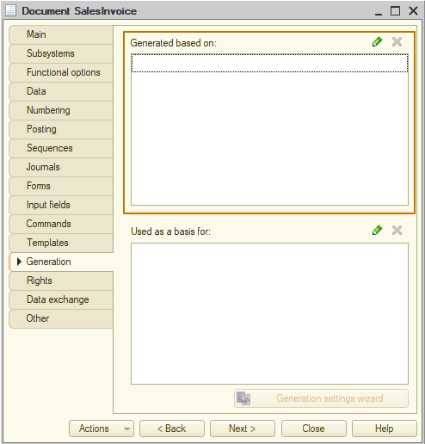
A situation may arise when the document was generated based on other object or from the code and the Customer attribute is filled in it. So the same algorithm must be performed - filling the contract with the main contract of the counterparty. But we can't use the code from the object's form module, because work with the form of the document is not carried out at the moment, only with the object. To do this, the algorithm should be transferred to the object module and made export, and it can be called from the form module to keep it work from the form too.
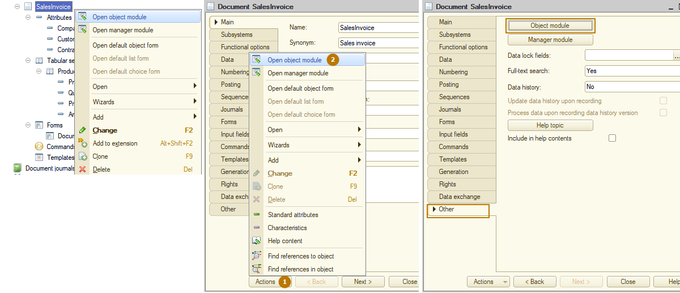
Ways to open an object module
Copy the FillMainContractAtServer procedure code, then open the object module, create the FillMainContract export procedure there and paste that code, removing the reference to the Object attribute, i.e. instead of Object.MainContract it should be just MainContract and so on, because in the context of an object module, there is neither a variable nor an attribute Object:
Next, we need to call the export procedure of the object module from the form module. In order to do this, you need to get an instance of the document object from the attribute Object of the form (the DocumentObject variable from the picture below contains an instance of the object), after which you can call built-in or export methods of this object. Upon completion of work with the object, it should be synchronized with the Object form attribute so that all changes that have occurred with the object are transferred to the form.
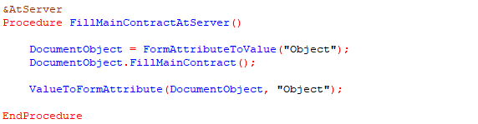
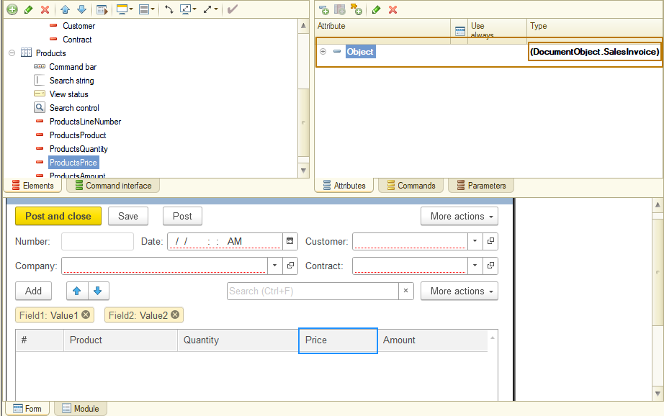
Main attribute of the form - Object, which is connected to an instance of the object
We cannot make the FillMainContractAtServer procedure non-context, because there is the work with the form attribute when we get an object instance from it, and then synchronize the object instance with the form attribute.

Processing tabular sections
Previously, we iterated the tabular section of an object on the client to keep the example simple. Now it should be noted that it is better to iterate the rows of the tabular section on the server, because on the client the tabular section contains only the visible part of the rows (the one that presents on the form at the moment), the rest of rows will be downloaded in portions from the server during iteration. Therefore, iterating a tabular section with hundreds of rows can result in multiple server calls, which will have a negative impact on performance.

